Answers to 2 and 5 not provided.

Question 1
- How would you describe a condition in which one attribute is dependent on another attribute when neither attribute is part of the primary key?

This demonstrates transitive dependency.

- Why is a table whose primary key consists of a single attribute automatically in 2NF when it is in 1NF?

If the 1NF table's primary key is not a composite attribute, then we can say the table is in 2NF. This is because it is not possible for any non-key attributes to be partially dependent on the primary key.

Question 3
Attribute Name | Sample Value | Sample Value | Sample Value
ITEM_ID | 231134-678 | 342245-225 | 254668-449
ITEM_LABEL | HP DeskJet 895Cse | HP Toner | DT Scanner
ROOM_NUMBER | 325 | 325 | 123
BLDG_CODE | NTC | NTC | CSF
BLDG_NAME | Nottooclear | Nottoclear | Canseefar
BLDG_MANAGER | I. B. Rightonit | I. B. Rightonit | May B. Next

- Show this group of attributes in 1NF.
- 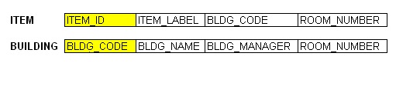
Write the dependency diagram to show this set of attributes in 2NF and 3NF. Label the partial and transitive dependencies on the diagram.

(2NF shown here)
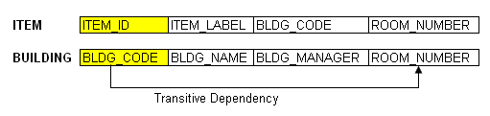
- Draw the ERD for this. Show cardinality.

(3NF shown here)
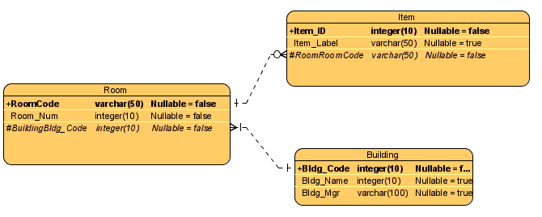

Question 4
Attribute Name | Sample Value | Sample Value | Sample Value | Sample Value
EMP_NUM | 1003 | 1018 | 1019 | 1023
EMP_LNAME | Willaker | Smith | McGuire | McGuire
EMP_EDUCATION | BBA, MBA | BBA |  | BS, MS, Ph.D.
JOB_CLASS | SLS | SLS | JNT | DBA
EMP_DEPENDENTS | Gerald (spouse),  Mary (daughter),  John (son) |  | JoAnne (spouse) | George (spouse)  Jill (daughter)
DEPT_CODE | MKTG | MKTG | SVC | INFS
DEPT_NAME | Marketing | Marketing | General Service | Info. Systems
DEPT_MANAGER | Jill H. Martin | Jill H. Martin | Hank B. Jones | Carlos G. Ortez
EMP_TITLE | Sales Agent | Sales Agent | Janitor | DB Admin
EMP_DOB | 23-Dec-1968 | 28-Mar-1979 | 18-May-1982 | 20-Jul-1959
EMP_HIRE_DATE | 14-Oct-1997 | 15-Jan-2006 | 21-Apr-2003 | 15-Jul-1999
EMP_TRAINING | L1, L2 |  | L1 | L1, L3, L8, L15
EMP_BASE_SALARY | $38,255.00 | $30,500.00 | $19.750.00 | $127,900.00
EMP_COMMISSION_RATE | 0.015 | 0.010

- Show this group of attributes in 1NF.
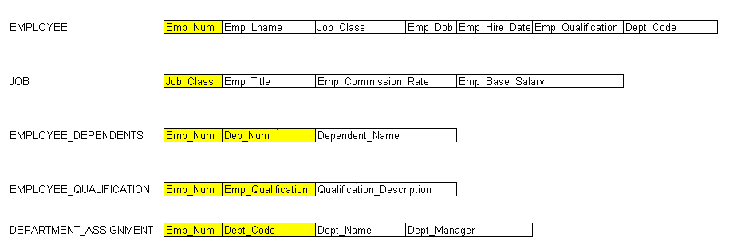

- Write the dependency diagram to show this set of attributes in 2NF and 3NF. Label the partial and transitive dependencies on the diagram.

(2NF – note renaming of attributes for job class
- note also training and education combined into Qualification.)
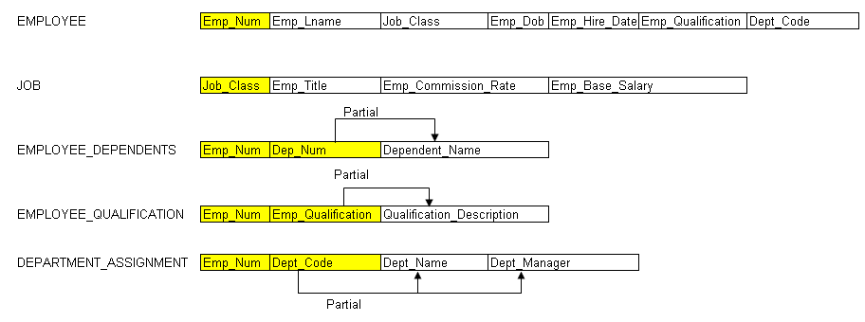
- Draw the ERD for this. Show cardinality.
(3NF shown here)
- Please note renaming may be done to align attribute names with entity names.

